07/02/2013
Vault 2014 API Language Pack

One of the neat things about the UI components in the SDK is that they are also used by the Vault clients. This means that when the product gets localized, the SDK components get localized automatically.
All you need to do is grab the satellite assemblies and distribute them with your app. Oh wait, you don’t need to do that. Dan Dulzo has already done this for you. Thanks Dan.
Click here to download the Vault 2014 API Language Pack
This should include all the langauges that Vault supports. If we missed one, let us know.

When to use
You should only use this for EXEs you write or when plugging in to a non-Autodesk application. If you are plugging in to an Autodesk product, the localization pack(s) should already be in place.
How to use
In the zip file are a bunch of folders with language codes for names. Grab the folders you want and place them under your EXE folder. For example, if your app is installed at c:\myApp\Program.exe, then your German language back would be at c:\myApp\de.
Don’t feel you need to have one language folder. Feel free to dump them all in your EXE folder. At runtime, Windows will load the appropriate language pack based on the OS settings. If your language isn’t in the language pack, the UI defaults to English, but you knew that already.
This language pack only supplies localizations of UI in the Vault SDK. Any UI you create yourself will have to be handled by you.

Screenshots
Here is the login dialog, which is invoked by the following code:
connection = VDF.Vault.Forms.Library.Login(null);
English:
German:

Here is an error dialog, which is being invoked from the following code:
catch (Exception ex)
{
VDF.Forms.Library.ShowError(ex, ex.Message);
}
English:
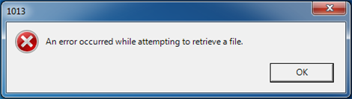
German:
